Photoshop “Andy Warhol Pop Art"

You are creating your own Pop Art- image of yourself. The page size for the Warhol is 8x10, 75 resolution. The size for the head shot image is 4x5, 75 resolution. Make changes to resize your headshot before you move it to the 8x10 canvas.
You will need a head shot of yourself from the shoulders up face forward. No hats or sunglasses. Make sure your image is sized, centered and cropped before you move it. Once moved to the 8x10 canvas, remove the color from the image. Image>adjustment>black and white>ok.
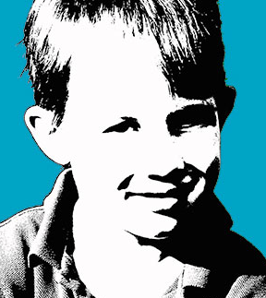
Now hold down the Alt key and left click mouse, you will do this three times and it will make three copies. Drag the images in place so there are four images.
Make a color grouping for each image. Give each grouping a color and name. Name groups top left, top right, bottom left bottom right.

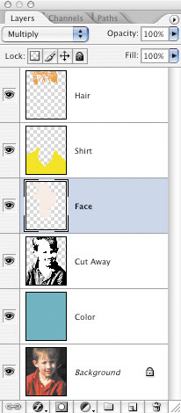
Select one of the group to work with turn the visibility button off on the others. Make the layer of your picture active, use selection tools of your choice to select areas you will add color (face, eyes, lips, hair, clothing). Once you have selected an area with your selection tool make it a separate layer, click Ctrl +Alt + J, and name the layer.
Color the layer using paint bucket, color balance, hue and saturation or other coloring techniques you may know. You may also want to use opacity if color does not look natural.
You are to color five layers in each image. Repeat this for each layer group
Color the background in a separate layer for each image
Create a border wide enough so it stands out around each of the four images.
Use your text tool and put your name on the bottom right of the full page color Warhol make it a color that stands out.

Remember all the layers in your group should be showing before you print screen for your picture package.
Print a black and white picture package name bottom right, make sure all of your layers are showing.
Print a full page color version.

